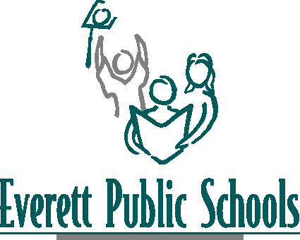

General Advisory Council
Everett Public Schools, Educational Service Center Room C3
January 25, 2007 - 10 – 11:30 a.m.

10:00 Welcome – Introductions

10:05 Council Norms

10:30 Manufacturing update

10:35 Presentation made to school board

11:00 Updates from Industry – teaching into the 21st century

What do student need to know about the world?
How do you think outside the box in your workplace?
How do you research an issue or problem? Where do you find reliable
information?
How do you develop people skills in your workplace? Are you required to
work in teams?

11:30 Adjourn

Upcoming meeting: April 19, 2007

